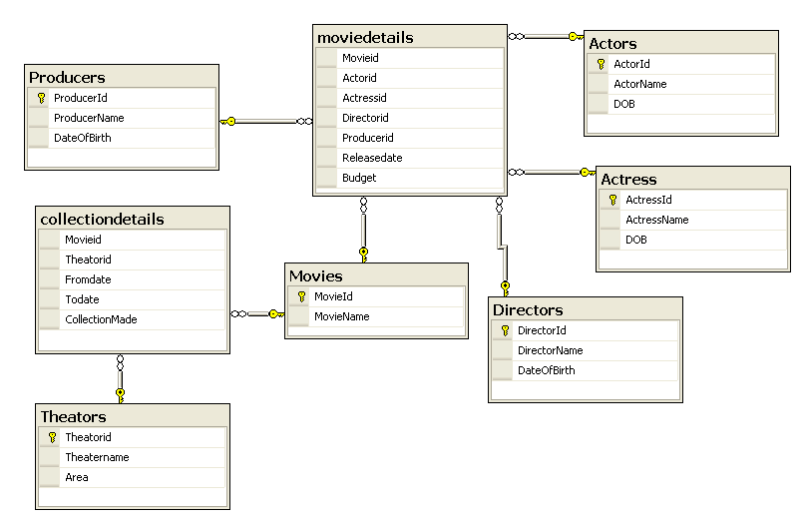

DROP TABLE MovieDetails;
DROP TABLE CollectionDetails;
DROP TABLE Actors;
DROP TABLE Actress;
DROP TABLE Directors;
DROP TABLE Producers;
DROP TABLE Theators;
DROP TABLE Movies;

CREATE TABLE Producers
(
ProducerID VARCHAR2(10) CONSTRAINT Prod_PID_PK PRIMARY KEY,
ProducerName VARCHAR2(20) ,
DOB DATE
);

CREATE TABLE Actors
(
ActorID VARCHAR2(10) CONSTRAINT Actors_AID_PK PRIMARY KEY,
ActorName VARCHAR2(20) ,
DOB DATE
);

CREATE TABLE Actress
(
ActressID VARCHAR2(10) CONSTRAINT Actress_AID_PK PRIMARY KEY,
ActressName VARCHAR2(20) ,
DOB DATE
);

CREATE TABLE Directors
(
DirectorID VARCHAR2(10) CONSTRAINT Director_DID_PK PRIMARY KEY,
DirectorName VARCHAR2(20) ,
DOB DATE
);

CREATE TABLE Movies
(
MovieID VARCHAR2(10) CONSTRAINT Movie_MID_PK PRIMARY KEY,
MovieName VARCHAR2(20)
);

CREATE TABLE Theators
(
TheatorID VARCHAR2(10) CONSTRAINT Theator_TID_PK PRIMARY KEY,
TheatorName VARCHAR2(20)
);

CREATE TABLE Collections
(
MovieID VARCHAR2(10),
TheatorID VARCHAR2(10),
FromDate DATE,
ToDate DATE,
CollectionMade NUMBER(6),
CONSTRAINT CDet_MID_FK FOREIGN KEY(MovieID) REFERENCES Movies(MovieID),
CONSTRAINT CDet_TID_FK FOREIGN KEY(TheatorID) REFERENCES Theators(TheatorID)
);

CREATE TABLE MovieDetails
(
MovieID VARCHAR2(10),
ActorID VARCHAR2(10),
ActressID VARCHAR2(10),
DirectorID VARCHAR2(10),
ProducerID VARCHAR2(10),
ReleaseDate DATE,
Budjet NUMBER(6),
CONSTRAINT MovieDet_MID_FK FOREIGN KEY(MovieID) REFERENCES Movies(MovieID),
CONSTRAINT MovieDet_AID_FK FOREIGN KEY(ActorID)REFERENCES Actors(ActorID),
CONSTRAINT MovieDet_AcID_FK FOREIGN KEY(ActressID )REFERENCES Actress(ActressID) ,
CONSTRAINT MovieDet_DID_FK FOREIGN KEY(DirectorID) REFERENCES Directors(DirectorID),
CONSTRAINT MovieDet_PID_FK FOREIGN KEY(ProducerID) REFERENCES Producers(ProducerID)
);

